## **HANDSON 3**

## **Objectives:**

* Explain branching and merging
* Explain about creating a branch request in GitLab
* Explain about creating a merge request in GitLab

**Steps Executed:**

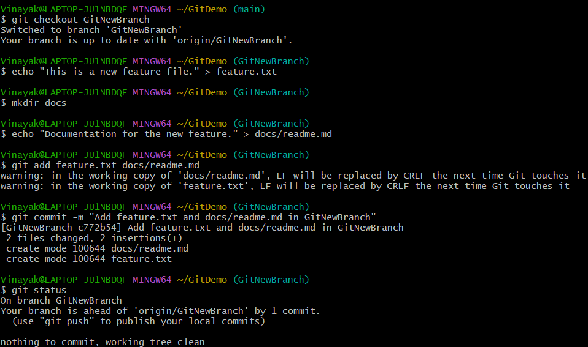

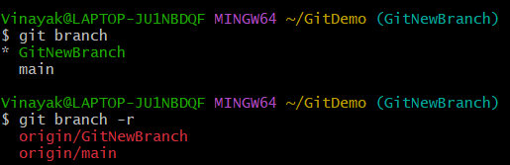

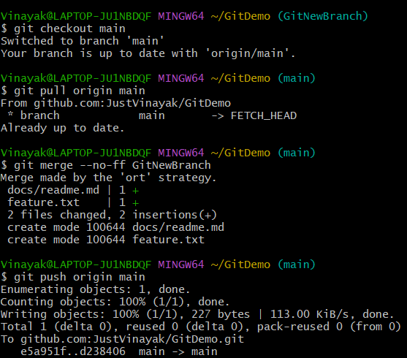

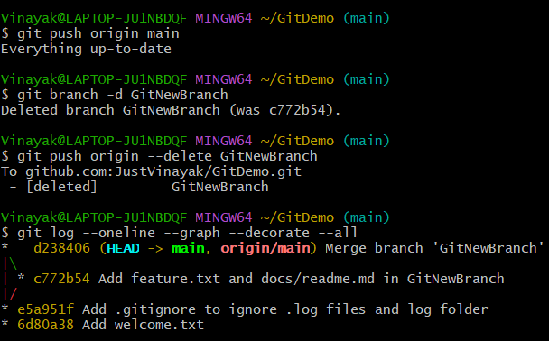

**Output:**

